3. Interference by division of wavefront

Huygens-Fresnel principle.

When a wavefront is limited by an aperture, enters a fundamental property of waves called Huygens – Fresnel principle.
The statement of H-F principle is the following.
" Any point reached by a wavefront is center of emission of secondary spherical waves... (part by Huygens for isotropic media)
... the secondary waves has amplitude and phase" (part by Fresnel).
One may think that Huygens says that empty space behaves as if where a kind of fog scattering light in all directions. Also it may be thought that the Fresnel contribution is a platitude. But the sum of both permits a calculation of the amplitude at any point by adding the secondary amplitudes with the corresponding phases depending on the optical paths between the original wavefront and the given point, and the result of that calculation is neither foggy nor obvious.
In other words, the fog has "coherence". By now, the meaning of this word is "the capacity for producing interference phenomena", in the same way as is said "energy is the is the capacity for producing work".
Because all waves satisfy a wave equation, the H-F principle may be hidden in some property of the wave equation.
It was Kirchhoff who derived the H-F "principle" starting with a wave equation.
The derivation is made for scalar waves, has many approximations, an is of value for a theoretical fundamentation.
But here it will be left as a principle. The point is to translate all what is told in words by an equation telling the same, but allowing the calculation of the pattern of light in particular cases. (This is a similar attitude to what is followed in quantum mechanics)

In reference to Fig. 3.1, the quation is
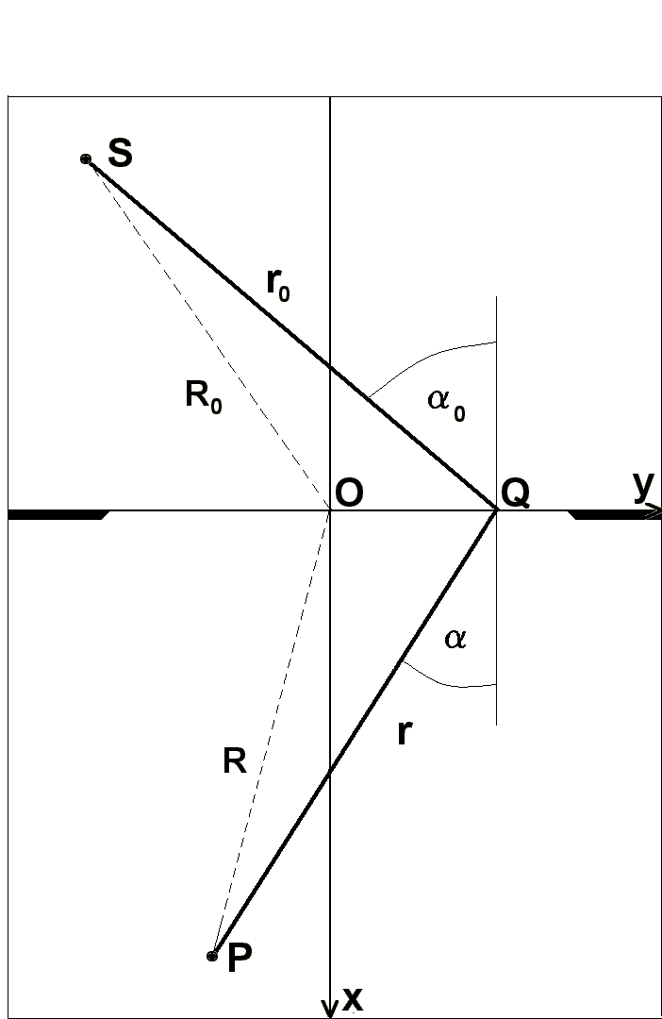
(3.1) 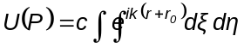
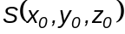 is the point from which there are emitted the primary waves.
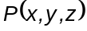 is the point where is to be evaluated the resulting amplitude.
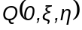 is a generic point scanning the transparent aperture.
The aperture is plane, and 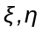 comprises all the values of y, z respectively, for wich the aperture is defined, that is, all transparent area elements of the y, z plane.
The factor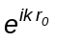defines the phase of the primary wave on the aperture. It is constant over a sphere centered in S.
The factor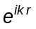defines the phase in P according to traveled path 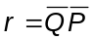
C is a quasi-constant of little variation in the configurations of practical interest, and contains ingredients such as a factor 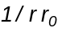 because they are spherical waves, an inclination factor valued 1 for the direction of the primary wave and 0 backwards, and also introducing the necessary
Fig 3.1
units for the validity of the equals sign.
In order to C be considered constant, the points S,P,Q cannot be very far from a straight line, neither can be S and P very near the aperture.
Besides, it must be 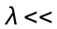 than all the intervening geometrical dimensions.
Equation (3.1) is a diffraction integral.
Diffraction means a departure from propagation by rays. The borders of the shadows show a fringe structure near the zone defined by rays.
The above statements are valid in this zone.

Diffraction by slits

Before going on with mathematical developments it's useful an intuitive glimpse on some simple cases.

Let be a plane wave normally incident on a screen, that is, 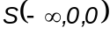. In Fig. 3.2 there are two slits of negligible width respect to their separation d. Point P of observation is at infinity in direction . If 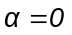, the optical path difference (and of phase) between waves coming from a and b is zero and the transmitted light is reinforced.

If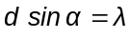there is also a reinforcement because the path difference is. This is the simplest case, and it can be seen that transmitted light in direction is a maximum if
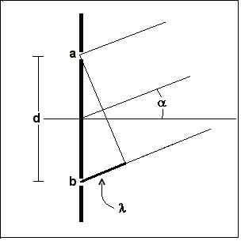

3.2) 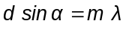

And is zero if

(3.3) 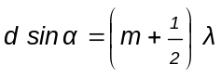,

Where m is a whole number.

In Fig. 3.3 there is another case: a slit of finite width s.

If it is sliced into infinitesimal elements, the wave originated in 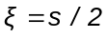cancels out with the one from o, for a direction such that

(3.4) 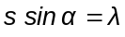

Because the path difference is 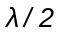. The same
Fig 3.2

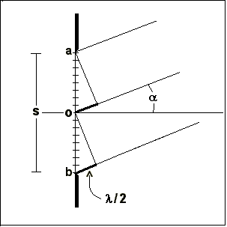
happens for each pair of elements separated by 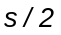, so

that in the direction the slit doesn't transmits light.

It can be guessed that transmitted light goes from zero to a maximum at .

The word "interference" is usually associated to the first case and "diffracction" to the latter, without clear reasons.

In Figs. 3.4 a and b the wavefront incides with an inclination 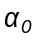 from the normal. The sign of the angles is shown. The path difference for a beam diffracted in any direction is 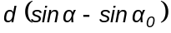

The particular directions studied before in both cases are the same, replacing 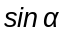 by 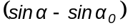.

Is worth noting that the diffracted direction in which the path difference is zero, is that of the incident beam.
Fig 3.3

Calculation of the diffraction integral

With equation (3.1) there can be solved in full detail the former configurations plus other much more complex. The problem reduces to obtain an expression for the integrand and perform the finite integral for each type of aperture.

It is
(3.5) 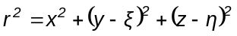

(3.6) 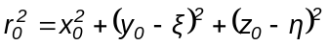

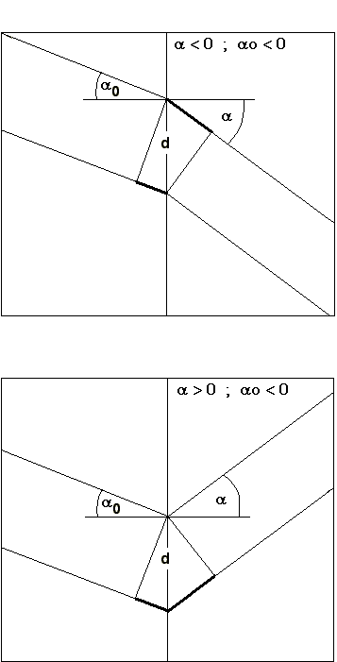
Let
(3.7) 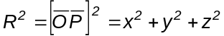

(3.8) 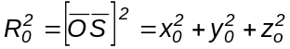

It is
(3.9) 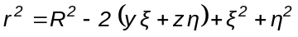

(3.10) 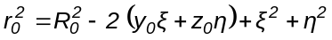

If 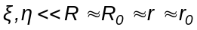 and a small quantity
It is
(3.11) 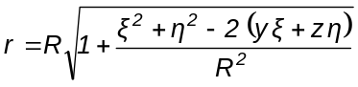
(3.12) 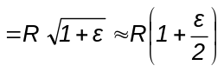
That is

(3.13) 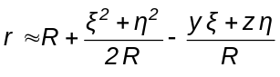
Fig 3.4 a and b

Also
(3.14) 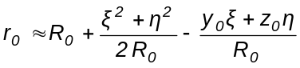

Introducing these expressions for and in the integral, the factor 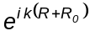 goes to be part of, and becomes

(3.15) 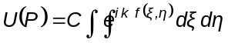
Where
(3.16) 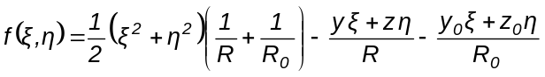

The quantities 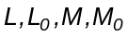 , defined by

(3.17) 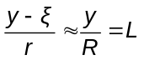

(3.18) 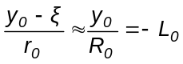
(3.19) 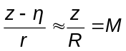

(3.20) 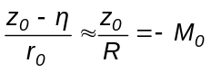

Are two of the direction cosines of 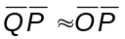 and of 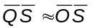
In terms of these
(3.21) 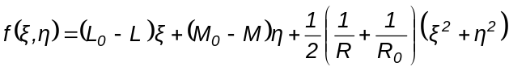

This formula defines the so called Fresnel diffraction, valid to find the pattern of light at medium distances.

Fraunhofer diffraction

If 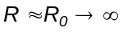 the quadratic term in vanishes and both the source and the receiving screen are infinitely far from the aperture. There are only directions of diffraction.
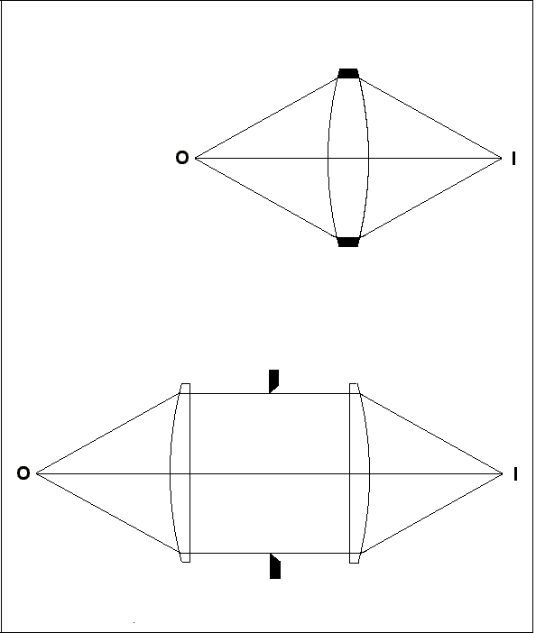
It is called Fraunhofer diffraction, and is important because it appears in the image forming optical instruments.
These instruments may be conceptually reduced to an ideal lens (The technical details will be shown later).
In Fig. 3.5 there is a lens forming the image of a point source at an arbitrary distance.
The rim of the lens define the aperture.
This configuration is fully equivalent to placing two lenses on both sides of a similar aperture so that the final cone of light be the same. The first lens has its focus at the source and a collimated beam pass through the aperture, that is, plane waves. On the aperture are given the conditions for Fraunhofer diffraction.
The direction cosines enter the formula as differences. Calling

(3.22) 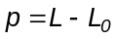 ; 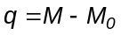

Not to be mistaken p with P = symbol of the generic point.

The Fraunhofer diffraction integral is
Fig. 3.5
(3.23) 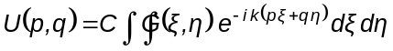

Pupil function

It was introduced above the pupil function 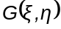, valued 1 for any within the aperture and 0 outside it, so that the integral may be done from 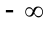 y 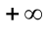 (a simple formality).
But the pupil function can be more interesting than a simple delimiter. It may be a continuous complex function. The incident wave is affected in amplitude and phase respectively, by
(3.24) 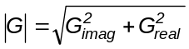
(3.25) 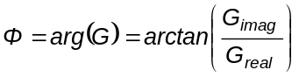

We see the formula for Fraunhofer diffraction dressed as a Fourier tansform.
In a lens its transparent part is called pupil. (A more precise definition will be given in the geometrical optics section). Then follows the important statement:
"The pattern of amplitude in the image formed by a lens is proportional to the Fourier transform of the pupil function"
A list of Fourier transforms may be a catalogue of diffraction patterns.
Now we return to the former cases with the new tool.
Both are one-dimensional patterns because the slits are infinitely long.
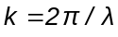, and in this case 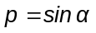
The integral turns to be the sum of the values of the function in the infinitesimal apertures.

(3.26) 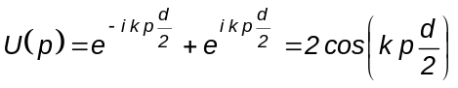

(3.27) 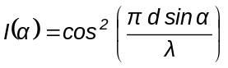

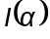 is a simple sinusoid whose period is inversely proportional to the separation a. They are the "Young fringes", the first experiment intended to show the wave nature of light.
We have resigned from start to follow a detailed account of the constants or quasi constants of proportionality. In this example, the intensity is infinitesimal. The constant is implicitly adjusted so that the absolute maxima of the functions are 1
In the wide slit, the only difference lies in the limits of the integral.

(3.28) 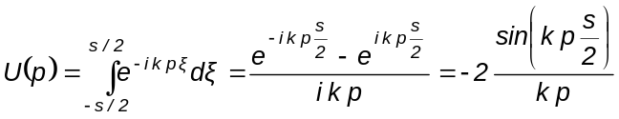

(3.29) 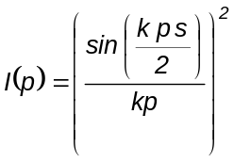

The first zero is for

Infinitely wide slit

The integral
(3.32) 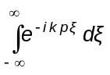
is the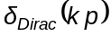. That is, the intensity is zero everywhere except one, in which goes all the energy. Correct, there is no diffraction.

Circular aperture

Almost all optical instruments have circular aperture, and because of this is important this case, illustrating a bidimensional configuration.
We define polar coordinates over the pupil

(3.33) 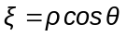 ; 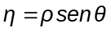

Light must incide perpendicular to the plane of the pupil, because otherwise the aperture is not circular but elliptic. It's defined an axis of circular symmetry. Let be the angle between a diffracted direction and the axis, and imagine a far screen ( it does't matter whether it is plane or spherical, because is small, so that 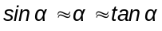)

(3.34) 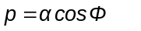 ; 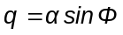

The exponent in the integral is

(3.35) 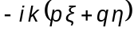

(3.36)

(3.37) 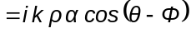
It follows

(3.38) 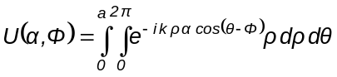

Where is the radius of the border of the pupil.
By symmetry, there is no dependence on 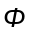. The integral is processed by means of Bessel functions and its relations. It is an exercise of special mathematics whose result is

(3.39) 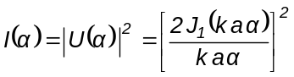

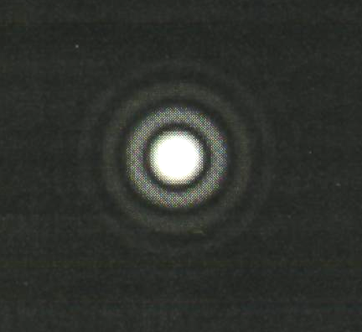
This is called the Airy function.
The light pattern has the aspect of a central disk surrounded by rings of rapid decreasing intensity, Fig. 3.6
The first zero, angular radius of the central disk, occurs for

(3.40) 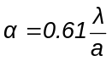

If there is formed an image at finite distance by means of a lens, the linear radius is obtained by the product with the focal distance f Fig. 3.6 (Suiter)

( 3.41) 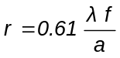

These formulae, to be well remembered, refer to radius.
Referring to diameters, the factor is 2.44. Often there appears in the literature a factor 1.22 linking diameters with radii and brings confusion.
This disk sets the resolving power of a telescope.

Example

CAsLeo telescope

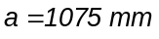 ; 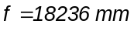 ; 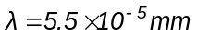

Results 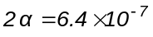rad. ≈ 0.13 ''
In the focal plane, 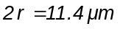
By atmospheric effects it is often some 10 or 15 times larger.

Effect of a central obstruction

In reflecting telescopes the center of the pupil is covered by the secondary mirror. The diffraction pattern is altered, and to calculate it is necessary to perform the radial integral from b to a, b being the radius of the obstruction.
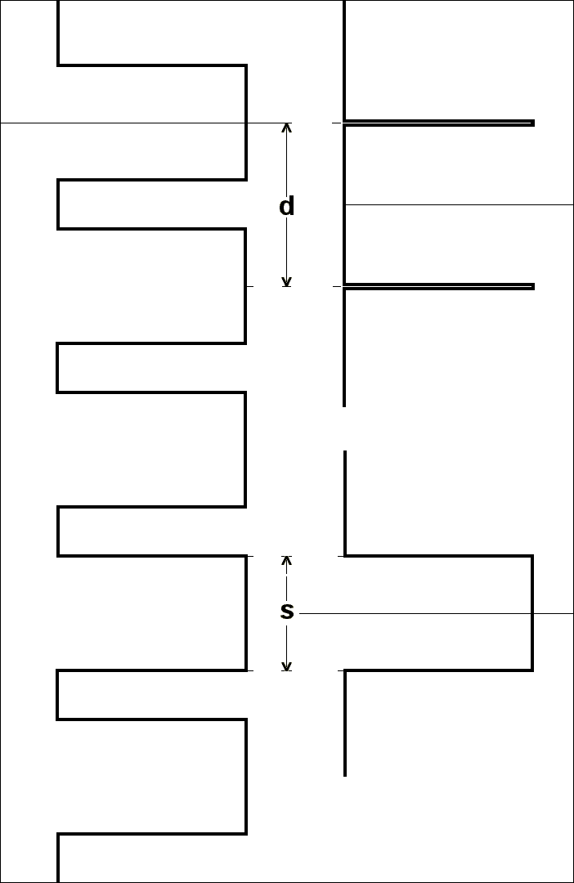
The observable consequence is a slightly reduced disk, and the first rings are more luminous. Hence the resolution is a bit larger and the contrast, or resolution of shades, is impaired because the rings form a halo near luminous points.
Diffraction grating

This is a most important and complex example, but the former considerations about slits had prepared the land. The elementary diffraction grating will be defined as a sequence of N+1 slits numbered from 0 to N, each one of width s and separated by a distance d.
There are several reasons to call it elementary:
The perturbation 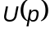 is scalar.
The pupil function is real.
The grating is plane.
The distance between slits is constant.
Some anomalous behaviors and technical developments stay out the discussion, but the model is fairly good. Later it will be introduced, in a non-rigorous way, a variant of this due to its importance in astronomical instruments.
In Fig. 3.7 there are shown schemes of two narrow slits, a wide slit and a diffraction grating.
It remain for the reader (optional), to apply the
Fig. 3.7
theorems about Fourier transforms to derive its optical properties
Each slit center is at a distance jd from origin, with j = 0,1, ..., N.
The diffraction integral is
(3.42) 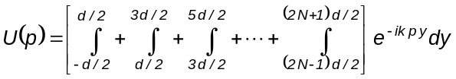

Changing variable in each integration, it may be extracted a common factor

(3.43)
(3.44) 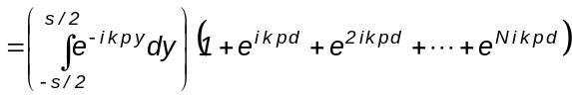
The first factor is the well known diffraction by a wide slit given by (3.28), where the interval of integration was changed to (-s/2 , s/2 ) because only in that zone is transparent.
The second factor is a truncated geometric series with N terms of ratio 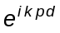.
Its sum is
(3.45) 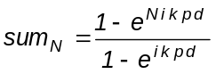
The intensity is 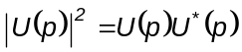, and remembering that 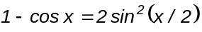
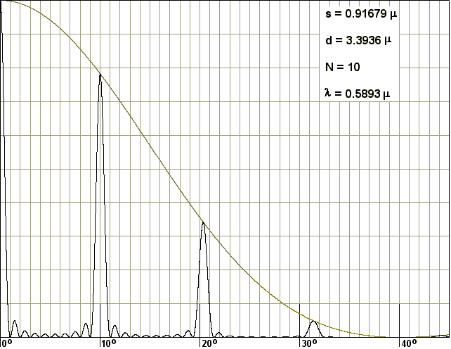
follows the so called instrumental function
(3.46)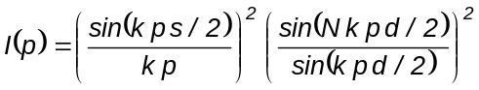
In general, the angle of incidence is any, so that 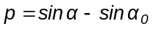
In Fig. 3.8 it is shown for sodium light normally incident. It is a plot of equation (3.46). The isolated peaks are the orders of diffraction. The parameters where set for the first factor (the smooth curve) to have its zero at 40 degrees and the first order at 10 degrees.

Exercise

Write down a program to generate these figures. Here is one.
Fig. 3.8
Listed ELEGRA
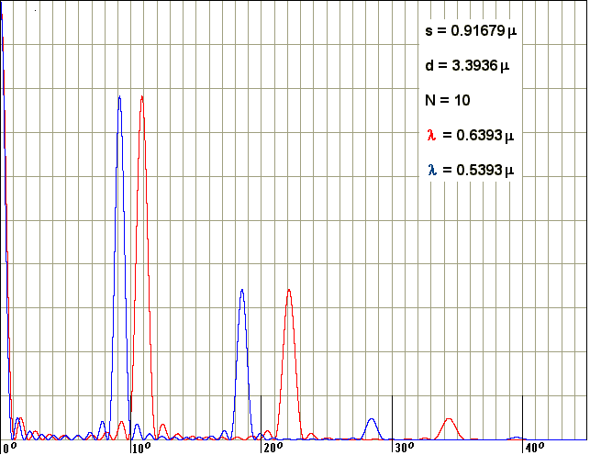
Compiled ELEGRA

Fig. 3.9 is the pattern of intensity for two different wavelengths. It is seen that the separation of the respective peaks increases with the order.
Besides, the width of the peak decreases when the number of slits increases, as it is seen in Fig. 3.10, that is the profile of the sodium double line, with
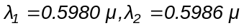
in first order, N = 982 , and all other parameters the same as in Fig 3.8. It is a much amplified portion of the zone around 10 degrees.
The double structure of the line is just visible now.
Fig. 3.9

We can conclude that the resolving power increases with the order and the number of slits.
Starting with equation (3.46) there may be derived other more practical ones.

Grating equation

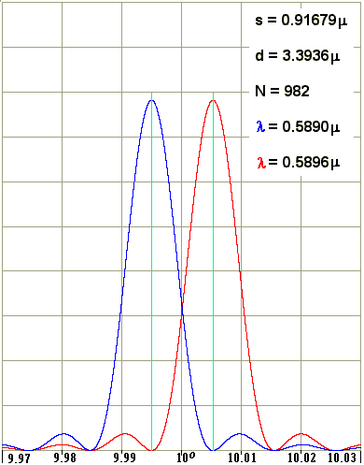
The orders are due to the zeros in the denominator of the second factor. For these also vanishes the numerator, and the indeterminacy is resolved giving 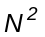. Hence is 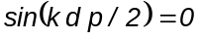, or 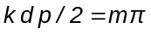
where m is the whole number identifying the order. This may be put as
(3.47) 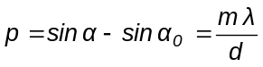

Equation (3.47) is called "the grating equation", and allows a determination of the direction of the orders

Resolving power

The resolving power is given by the semi-width of each order. The first zero following a peak is produced for a variation 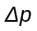 so that 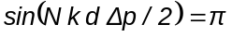, or
(3.48) 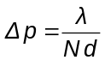
Fig 3 .10
If changes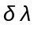, by the grating equation is
(3.49) 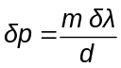
In order that to two be separated, it must be 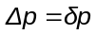, or
(3.50) 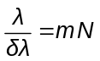

Equation (3.50) is the formal definition of resolving power.

Example

In the sodium doublet is 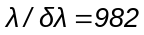, and a grating resolving it in m = 1 must have 982 slits or lines. In Fig. 3.10 it is seen that these figures refer just to orders of magnitude, for if it is true that the peak of acoincides with the zero of the other, with a sensitive detector they may be separated with less lines.
It is illustrative to write (3.50) as

(3.51) 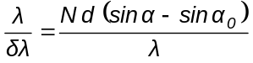

replacing the value of m from the grating equation. It is seen that the resolving power is the number of wavelengths within the optical path difference between the first and last line, separated by a distance Nd . This is to be expected, because that line pair produces the narrowest fringes. The factor 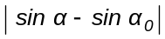 cannot exceed 2 , for grazing incidence and very high order. Therefore, the resolving power is almost 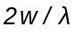, where w is the ruled extension of the grating.
Free spectral range

If two are different enough, they may be diffracted in the same direction, one in order m and the other in m+1. This would be a great mess for anyone trying to interpret a spectrum. Using the grating equation this condition implies

(3.52) 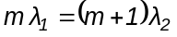

The spectral range for which there is no superposition is 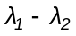.
To put it in a similar form to (3.51),

(3.53) 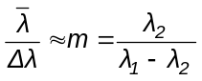
Intensities
The instrumental function (3.46), also permits a calculation of the intensities of the orders. These are given by the first factor, depending on the form of the groove or slit or line.
In its elementary form, light is sent mainly to the zero order, but the grating equation says that there the's do not separate, and that light is wasted. Moreover, only a fraction 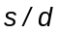 of the grating is transparent.
In any instrument it is convenient the greatest possible transmittance, but in astronomical instruments is very critical.
Recalling that the pupil function may have modulus and phase, it would be very interesting one purely imaginary, having only phase periods, for this would be all transparent.
We have seen that the maximum of diffraction by a single slit is in the direction of the incident light. If we place a mirror behind, it would be in the direction of the reflected light. As we assumed up to now a plane grating, this does not means anything new, simply the transparent portions turns reflecting.
But if each elementary mirror is tilted by a certain angle (the same for all), the maximum of diffraction will go where the reflection law indicates, and there is no need of opaque portions. The period is given by each little mirror.
Besides, the direction of the orders are given by the incident light and the characteristics of the grating, but are refered to its plane .
Eureka!.
By tilting the mirrors adequately, the maximum can be driven to any direction, where there is good spectral information, and in addition it may be left the zero order in the dark.
It is not necessary for the grating to be of reflecting type. The same effect may be achieved by transmission, with prisms.
This arrangement is called blaze,
Also there is the possibility of producing a sinusoidal phase function. Fourier theory tells us that this grating has only orders 1 and –1.

The most general is to leave the first factor as a definite integral and solve for each case.
It may arise the inverse problem: from a given distribution of intensities, to derive the form of the period. There may be too bi and tri-dimensional gratings. A tri-dimensional grating is, for instance, a crystal (periodic arrangement of molecules) iluminated with X rays. With the same theory, but with much more mathematical complexity, it may be derived the structure of the molecule. The crowning achievement is the structure of ADN, but this is not astronomy.

Back to the principle.

We have seen how to use Huygens-Fresnel principle to solve some practical problems. We may take it again in theoretical mode because it has still more details.
Another very famous principle is Fermat's, that states:
"The trajectory of a light ray is such that it makes the time of travel be stationary respect to contiguous trajectories"
As it is still unclear, we appeal to the case of the hurried bather, a classic to explain it . (Fig. 3.11)
A bather is sinking at B, and a rescue swimmer is at N.

On land, the swimmer moves at speed and swimming, at speed 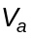 ( > ). ¿Wich point P must aim to reach earliest to B?
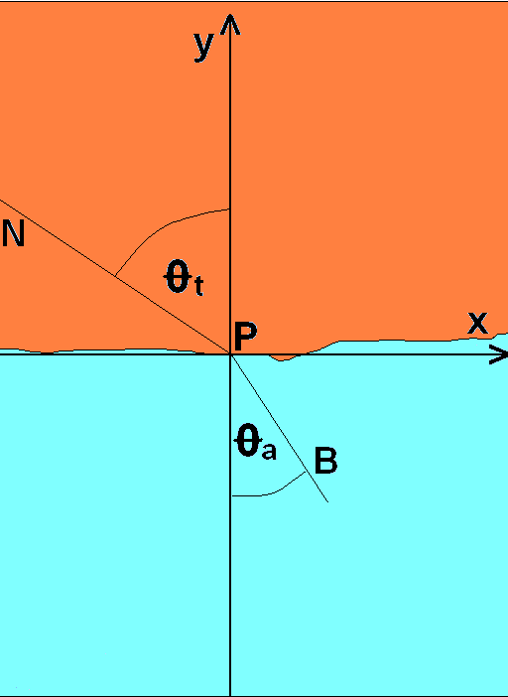


The total time of travel is

(3.42) 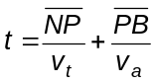

Point 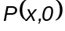 is variable, and x is the parameter ordering the various trajectories.
Therefore

(3.43) 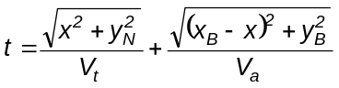
It must be

(3.44) 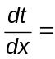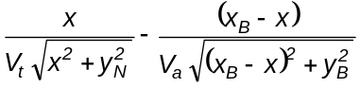 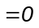
That is,
3.45) 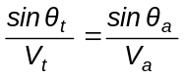

Fig 3.11

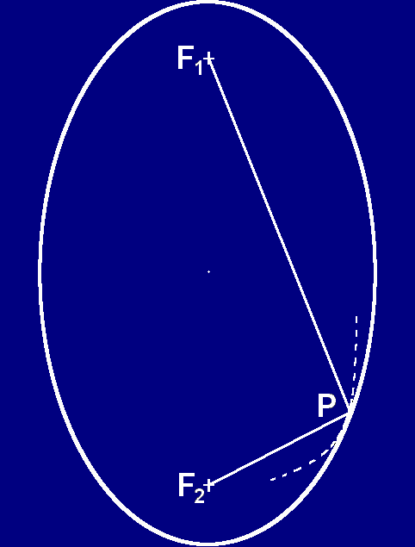

The rescuer obeys Snell law .
Asked a rescuer, he replied that he prefer to not loss time in calculations.
As the Fermat principle refers to contiguous trajectories, it is said that it is differential and local, and do not hinders a lamp to be seen directly and at the same time from a mirror.
To illustrate a less usual case, let's consider a ray 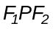 going from a focus in an elliptical mirror to the other focus. (Fig 3.12) Whichever be P, the distance 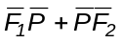 is the same, then 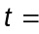 constant, and the Fermat principle is very well fulfilled. (This is the optical definition of focus). If we consider the dashed curve, tangent to the ellipse in P and interior to it in other points, the trajectory is of maximum time. For this reason it is not correct to say a minimum
And what has this to do with Huygens-Fresnel principle?
The H-F principle explains Fermat's.
The point of stationary time is also of stationary optical path and of stationary phase. The phases associated to contiguous trajectories change slowly and their amplitudes sum up with the same sign. In other points the phase changes faster and these trajectories do not contribute noticeably. The H-F principle explains the smell of light to find its trajectory.
Effectively explores all possible trajectories, and some go through them as diffracted light.
These principles has importance beyond optics due to the wave
Fig 3.12
nature of all physics

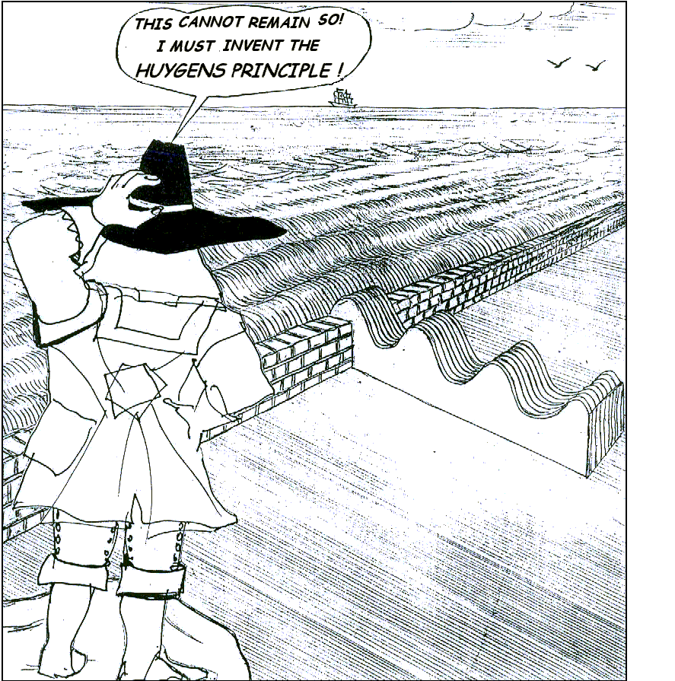

This may once happened in Holland.
A guy Christiaan Huygens looks at the pounding of waves on an opening in a dike.

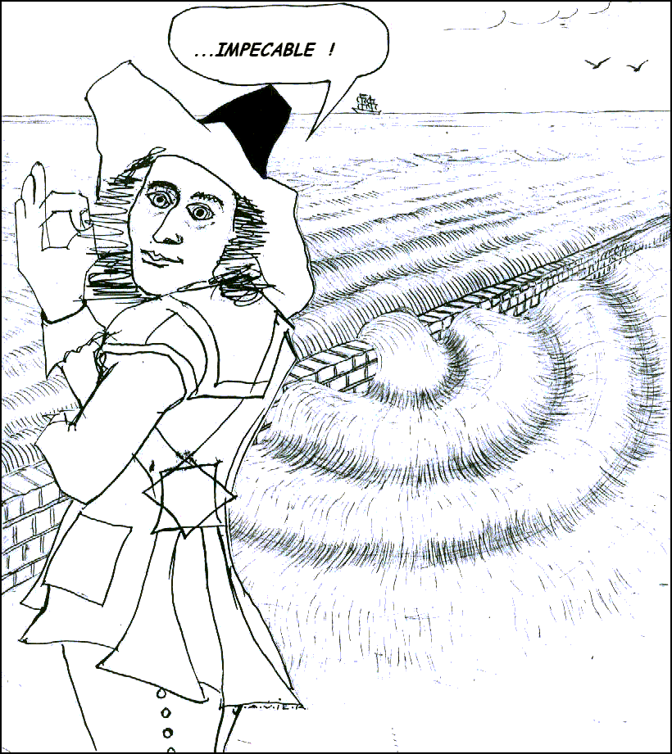

Before reaching the dike, the waves are straight because each part lean on its neighbors.
Having passed the opening, they spread in all directions because they has not where to rely.

Elementary, Christiaan!

